

For Patients Visiting the Cardiology/Cardiovascular Surgery Department

|  |  |
| --- | --- |
| Name : | Age : |
| Email address : | Tel： |

1. **Please list the people you live with.**
2. **What are the reasons/symptoms you are visiting for, and when did they start?**

Ex) An abnormality was found on my electrocardiogram at my health checkup/I have had occasional chest tightness for the past year/I have been feeling out of breath when walking for the past 2-3 days, etc.

1. **Have you ever been diagnosed with any illnesses? Have you ever been hospitalized or undergone surgery?**

Allergies  ( NONE ・ YES → What are you allergic to? (Ex: Medicine, contrast, pollen, food, etc.others: _________)

Asthma ( NO ・ YES → When was your last attack? ( ) Diabetes ( NO ・ YES, from age _ )

High Blood Pressure. ( NO ・ YES, from age )

Other illnesses

(Diagnosis: at age  ), Surgery (NO ・ YES ) (Diagnosis: at age  ), Surgery (NO ・ YES ) (Diagnosis: at age  ), Surgery (NO ・ YES )

1. **For women: Is there a possibility you are currently pregnant?** **( NO ・** **YES )**
2. **If you take any regular medicine, please list them below. (Please show us your medication record if you have one)**
3. **Do you have a primary care hospital/clinic?**
4. **Do you smoke?**

* YES, I used to smoke ____________ cigarettes/day for __years.
* NO

1. **Do you drink alcohol?**

NO ・ YES (If YES, write down the amount you drink in 1 day.)

Example: 2 glasses of wine/2 times a week  ( )

1. **Do you have any family members with the following diseases?**

If yes, circle the diagnosis and specify the family member’s relationship to you in the parentheses.

Example: High blood pressure (Mother)

High blood pressure ( ) ・ Cardiac disease ( ) ・ Diabetes ( ) ・ Stroke ( ) Cancer ( ) ・ Psychiatric disorder ( ) ・ Asthma ( ) ・ Other ( )

1. **Tell us your height and weight.**

Height: cm/ft. Weight: kg/lbs.

1. **Please answer the below regarding your** **mental state**.

* Please circle the amount of pain you currently have, with 10 being the worst pain you can imagine.

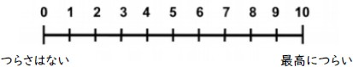

No pain

Worst pain ever

* Please circle the below number that best averages how difficult the past week has been for you.



Not at all

Extremely

* To what extent did that difficulty affect your daily life?



Not at all

Extremely

1. **Do you currently feel pain in your body? (Please circle the area and the appropriate level of pain below.)**

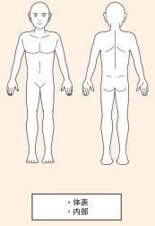

・External

・Internal

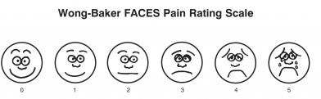

**Thanks for your cooperation!**